sa/lqc/oac 08

Zhuhai Study Tour

Pre-Departure Memorandum

Date: 15-17 Nov 2024 (3 days)
No. of participants: 103 students + 3 Staff
Location: Zhuhai, China

Staff-in-Charge:
Name |  | Contact (WhatsApp)
Trip Leader | Mr. Franky Fong  Ms. Angelina Chan  Ms. Penny Lo  Ms. Nicole Cheung  Mr. Hennessey Cheng | +852 6043 5916  +852 3411 5913  +852 9503 7978
HK Enquiries and Emergency Contact | Mr. Jeff Cheung | +852 3411 2333

- Important Time

Departure  Date: 15 Nov 2024 (Fri)  Gathering Time: 08:00 (please be on-time)  Gathering Point: G/F, School of Continuing Education, HKBU  Arrival  Date: 17 Nov 2024 (Sun)  Depart from Zhuhai at 16:00  Estimated Arrival: 20:00 @ Kowloon | 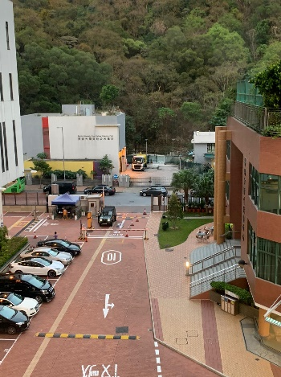

- Local Emergency Contacts
Local Emergency Contacts | Details | Mobile / Contact  (including country code)
Leadership Qualities Centre, HKBU | Jeff Cheung | +852 3411 2333
Zurich Emergency Assistance Hotline | Policy No.: TTT0001125ZC | +852 2886 3977

- Packing Checklist
Travel Document  - HKID Card  - Passport with Visa  - The Mainland Travel Permit  - Student Card  Wear  - Tees and pants  - Sleepwear  - Underwear  - Socks and shoes  - Slipper  - Thin coat  Dress Code for High Table Dinner  - Suit shirts (male)  - Ties (male)  - Trousers  - Leather shoes  - Long black socks (male)  - Formal dress (female)  - Gown | Daily Necessity  - Water bottle  - Personal medicine  - Backpack  - Umbrella / raincoat  - Snacks  - Skincare & sunscreen  - Mosquito repellent patch  - Tissue paper  - Cash (HKD, RMB)  Personal Hygiene  - Comb  - Towel  - Toothbrush/ toothpaste  - Shampoo  - Body wash  - Skin care items  - Shaver (male)  - Sanitary pad (female) | Others  - Camera  - Charger  - Adaptor

Etiquette for High Table Dinner
- You must follow the dress code strictly, i.e. Lounge Suit with a black gown. The black gown was given to you during your payment. The organiser reserves the right to refuse students with improper attire to attend High Table Dinner.
- To respect the guest speaker(s) and other attendees during the event, students should refrain from talking, playing, and other improper behavior such as the use of cell phones and electronic products when the guest speaker is delivering a speech. The organiser has the right to request misbehaved students to leave during the programme, and attendance will NOT be counted.

Rules and Regulations of the Outbound Trip
All participants must comply with the following rules throughout the outbound trip:
1. Join all assigned activities and not to leave the group without prior approval.
2. Be punctual for all activities and keep the place clean.
3. No absence in dining is allowed unless with prior approval / justifiable reasons.
4. Refrain from any unauthorised alcohol consumption, smoking, use of illegal drugs, and/or gambling
5. Foul languages and insulting words are strongly prohibited.
6. Follow the order from the organiser first. Appeal comes later.
7. Stay in the assigned accommodation. Exchange of rooms is not allowed without prior approval.
8. Prohibit anyone, excluding your assigned roommate(s), from staying overnight in the assigned accommodation.
9. Staying at your accommodation after 11p.m. is required. Lower the sound level as appropriate.
10. Adhere to the rules and regulations of the place where you stay. Keep the furniture in place and in order.
11. Take good care of your belongings. The organiser does not accept responsibility for any loss due to theft or burglary.
12. Assume any liability for any violations of the local and international laws.

